- Helping a customer
If we don’t take care of our customers, someone else will

Your most unhappy customers are your greatest source of learning -Bill Gates

- Watch the film
How to sell me a pen (Biro)
Answer next questions .(Dutch)
- What is the name of the pen introduced to us?
- From which country did he took it?
- It’s writing speed is faster due to what?
- In what colours can it be delivered?
- He is excited by the click of what?
- What is the clip on the lid for?
- What is de price of this pen?
- How did he test the heat resistance?
- What was the result of the water test?
- How long could you probably use this pen?

- The Ten Commandments of Customer Service
- Know who is boss. You are in business to service customer needs, and you can only do that if you know what it is your customers want. When you truly listen to your customers, they let you know what they want and how you can provide good service. Never forget that the customer pays our salary and makes your job possible.

- Be a good listener. Take the time to identify customer needs by asking questions and concentrating on what the customer is really saying. Listen to their words, tone of voice, body language, and most importantly, how they feel. Beware of making assumptions - thinking you intuitively know what the customer wants. Do you know what three things are most important to your customer?
Effective listening and undivided attention are particularly important on the show floor where there is a great danger of preoccupation - looking around to see to whom else we could be selling to.
- Identify and anticipate needs. Customers don't buy products or services. They buy good feelings and solutions to problems. Most customer needs are emotional rather than logical. The more you know your customers, the better you become at anticipating their needs. Communicate regularly so that you are aware of problems or upcoming needs.

- Make customers feel important and appreciated. Treat them as individuals. Always use their name and find ways to compliment them, but be sincere. People value sincerity. It creates good feeling and trust. Think about ways to generate good feelings about doing business with you. Customers are very sensitive and know whether or not you really care about them. Thank them every time you get a chance.
On the show floor be sure that your body language conveys sincerity. Your words and actions should be congruent.
- Help customers understand your systems. Your organization may have the world's best systems for getting things done, but if customers don't understand them, they can get confused, impatient and angry. Take time to explain how your systems work and how they simplify transactions. Be careful that your systems don't reduce the human element of your organization.

- Appreciate the power of "Yes". Always look for ways to help your customers. When they have a request (as long as it is reasonable) tell them that you can do it. Figure out how afterwards. Look for ways to make doing business with you easy. Always do what you say you are going to do.

- Know how to apologize. When something goes wrong, apologize. It's easy and customers like it. The customer may not always be right, but the customer must always win. Deal with problems immediately and let customers know what you have done. Make it simple for customers to complain. Value their complaints. As much as we dislike it, it gives us an opportunity to improve. Even if customers are having a bad day, go out of your way to make them feel comfortable.

- Give more than expected. Since the future of all companies lies in keeping customers happy, think of ways to elevate yourself above the competition. Consider the following:
  - What can you give customers that they cannot get elsewhere?
  - What can you do to follow-up and thank people even when they don't buy?
  - What can you give customers that is totally unexpected?

- Get regular feedback. Encourage and welcome suggestions about how you could improve. There are several ways in which you can find out what customers think and feel about your services.
  - Listen carefully to what they say.
  - Check back regularly to see how things are going.
  - Provide a method that invites constructive criticism, comments and suggestions.

- Treat employees well. Employees are your internal customers and need a regular dose of appreciation. Thank them and find ways to let them know how important they are. Treat your employees with respect and chances are they will have a higher regard for customers. Appreciation stems from the top. Treating customers and employees well is equally important.

stems | stamt, komt van | commandments | geboden
truly | echt | provide service | serviceverlenen
possible | mogelijk | identify | vaststellen, herkennen
importantly | belangrijk | beware | pas op
assumption | veronderstelling | preoccupation | vooringenomenheid
undivided | onverdeeld | attention | aandacht
anticipate | aanvoelen | upcoming | opkomende
appreciated | gewaardeerd | sincere | oprecht
to value | waarderen | trust | vertrouwen
generate | voortbrengen | sensitive | gevoelig
show floor | uitvoering | convey | overbrengen
congruent | overeenstemmend | confused | in de war
impatient | ongeduldig | reduce | verminderen
request | verzoek | apologize | verontschuldigen
complain | klagen | improve | verbeteren
expected | verwacht | elevate | verheffen
regard | dunk, kijk
In which paragraph do you find a match? (Put the number in the frame; discuss with your partner)
- Customers do not know how things work.
- Good contact with your customers is essential.
- Do something with your customers’ remarks.
- Treat your staff in the same way as your customers.
- The customer is actually your boss.
- Do whatever you promised.
- Be better than your competitors.
- Do not be preoccupied.
- Even if the customer is not right he must win.
- Make feel people special.

- Dialogue
Write down at least 20 questions to ask your partner. Write down the given answers. The subject must be work, internship or hobby, so sellings. You may ask whatever you want concerning practice.
Avoid closed questions (yes or no). Use: why, when, who, what, where….

- 50 BASIC ENGLISH QUESTIONS (practice with your partner)
Here are 50 basic (American) English questions with responses.
Personal Information
What's your name? | Peter.
Where are you from? / Where do you come from? | I'm from ... I come from ...
What's your surname / family name? | Smith.
What's your first name? | Tom.
What's your address? | 7865 NW Sweet Street
Where do you live? | I live in San Diego.
What's your (tele)phone number? | 209-786-9845
How old are you? | Twenty-five. I'm twenty-five years old.
When / Where were you born? | I was born in 1961 / Seattle.
Are you married? / What's your marital status? | I'm single.
What do you do? / What's your job? | I'm a florist.
Where did you go? | I went to a friend's house.
What did you do? | We worked in the garden.
Where were you? | I was in New York for the weekend.
Have you got a car / job / house / etc.? | Yes, I've got a good job.
Have you got any children / friends / books / etc.? | Yes, I've got three children - two boys and a daughter.
Can you play tennis / golf / football / etc.? | Yes, I can play golf.
Can you speak English / French / Japanese / etc.? | No, I can't speak Japanese.
Could you speak English / French / Japanese / etc. when you were five / two / fifteen / etc. years old? | Yes, I could speak English when I was five years old.
Introducing Yourself / Saying Hello
How do you do? | How do you do. Pleased to meet you.
How are you? | Fine, thanks. And you?
Shopping
How can I help you? / May I help you? | Yes. I'm looking for a sweater.
Can I try it on? | Sure, the changing rooms are over there.
How much does it cost? / How much is it? | It's $45.
How would you like to pay? | By credit card.
Can I pay by credit card / check / debit card? | Certainly. We accept all major cards.
Have you got something bigger / smaller / lighter / etc.? | Certainly, we've got smaller sizes as well.
Asking Something Specific
What's that? | It's a cat!
What time is it? | It's three o'clock.
Can / May I open the window? | Certainly. It's hot in here!
Is there a bank / supermarket / pharmacy / etc. near here? | Yes. There is a bank on the next corner next to the post office.
Where is the nearest bank / supermarket / pharmacy / etc.? | The nearest pharmacy is on 15th street.
Who wrote / invented / painted / etc. the ...? | Hemingway wrote "The Sun Also Rises".
Is there any water / sugar / rice / etc.? | Yes, there's a lot of sugar left.
Are there any apples / sandwiches / books / etc.? | No, there aren't any apples left.
Is this your / his / her / etc. book / ball / house / etc.? | No, I think it's his ball.
Whose is this / that? | It's Jack's.
Questions with 'Like'
What do you like? | I like playing tennis, reading and listening to music.
What does he look like? | He's tall and slim.
What would you like? | I'd like a steak and chips.
What is it like? | It's an interesting country.
What's the weather like? | It's raining at the moment.
Would you like some coffee / tea / food? | Yes, thank you. I'd like some coffee.
Would you like something to drink / eat? | Thank you. Could I have a cup of tea?
Asking for an Opinion
What's it about? | It's about a young boy who encounters adventures.
What do you think about your job / that book / Tim / etc.? | I thought the book was very interesting.
How big / far / difficult / easy is it? | The test was very difficult!
How big / far / difficult / easy are they? | The questions were very easy.
How was it? | It was very interesting.
What are you going to do tomorrow / this evening / next week / etc.? | I'm going to visit some friends next weekend.
Suggestions
What shall we do this evening? | Let's go see a film.
Why don't we go out / play tennis / visit friends / etc. this evening? | Yes, that sounds like a good idea.

Social dialogue: Shopping for a Sweater
- Can I help you?
- Yes, I'm looking for a sweater.
- What size are you?
- I am an extra-large.
- How about this one?
- Yes, that's nice. Can I try it on?
- Certainly, there's the changing rooms over there.
- Thank you.
- How does it fit?
- It's too large. Do you have a large?
- Yes, here you are.
- Thank you. I will have it, please.
- OK, how would you like to pay?
- Do you take credit cards?
- Yes, we do. Visa, Master Card and American Express.
- OK, here is my Visa.
- Thank you. Have a nice day!
- Thank you, goodbye.
Key Vocabulary
Can I help you?
Can I try it (them) on?
size - extra small, small, medium, large, extra large
How does it fit?
changing rooms
How would you like to pay?
credit cards
Practice this exercise with your partner until you know it by heart.

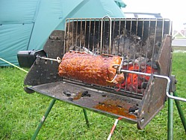 | 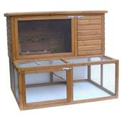 | 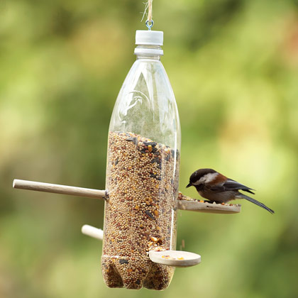 | 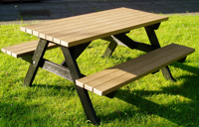
A | B | C | D
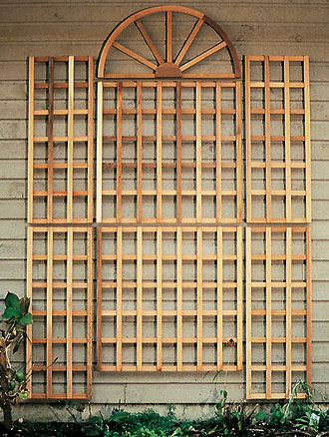 | 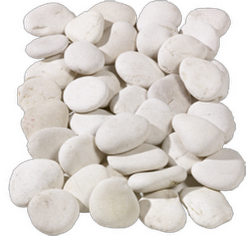 | 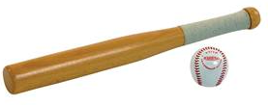 | 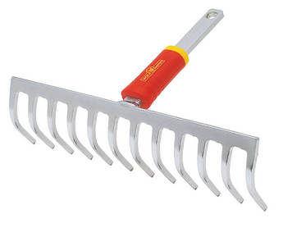
E | F | G | H
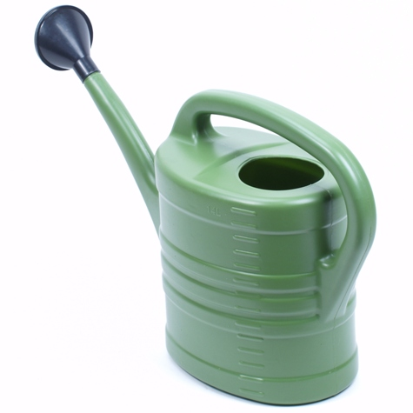 | 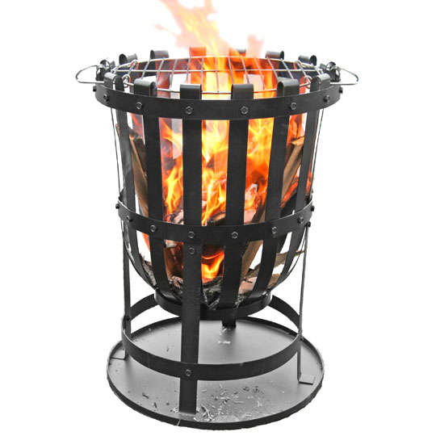 | 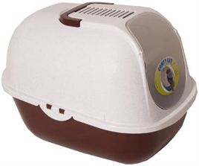 | 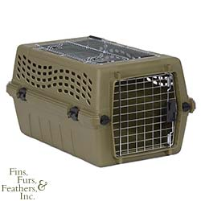
II | J | K | L
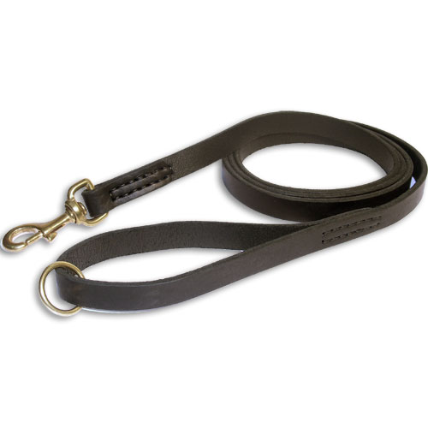 | 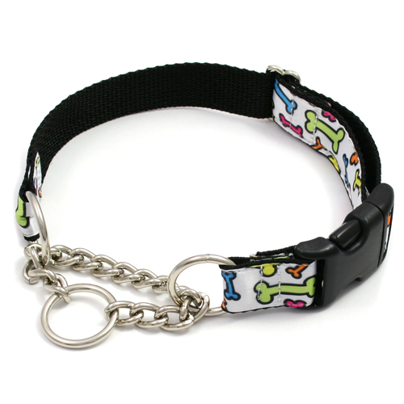 | 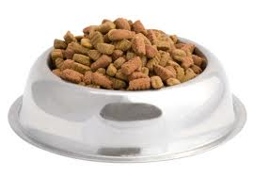 | 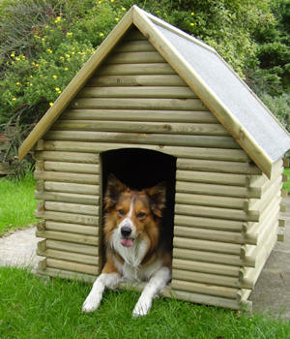
M | N | O | P
 | 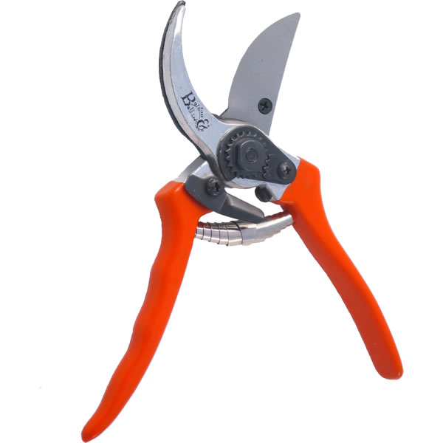 | 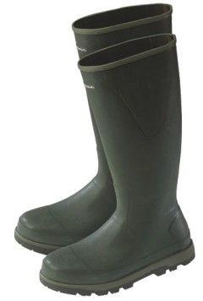 | 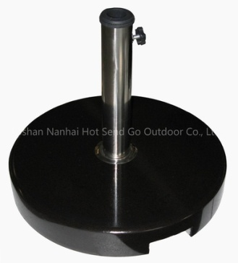
Q | R | S | T

Put the right letter in the right place
 | base |  | bench
 | boots |  | draaispit
 | brazier |  | gieter
 | collar |  | halsband
 | dog house |  | hark
 | feeder |  | hondenhok
 | leash |  | houtbak
 | litter box |  | kattenbak
 | log holder |  | kiezels
 | manger |  | konijnenhok
 | pebbels |  | laarzen
 | pet carrier |  | lijn
 | picnic bench |  | picknicktafel
 | rabbitshack |  | scherm
 | rake |  | slaghout en bal
 | rotisserie |  | snoeischaar
 | secateur |  | standaard
 | stick and ball |  | voederautomaat
 | trellis |  | voerbak
 | watering can |  | vuurkorf

- Message
You worked all day long. All at once you remember an appointment. At five you have to visit your dentist. You write down a note for your colleague who must work after five o’clock. You took care of cleaning, unpack and stocking shelves, but you did not yet remove the paper and boxes.
Miss Rose Walker called about the pet toys she ordered. She wanted us to deliver it tonight. Please call her in order to manage things properly.
- Classify
On the next page you will find articles from a shop. You have to categorize them in this list.
Discuss, of course in English, your choices with your partner.
gifts

number the catagories
 | jellycat |  | Britain
 | home accessories |  | glasses
 | kitchenware |  | kids corner
 | toiletries |  | smurfs
 | choco cat |  | hand made
 | body warmers |  | my melody
 | boxed mugs |  | other
 | Emma Bridgewater |  | jewellery
 | kimmidols |  | mugs with spoon
 | scarves |  | ceramics

8
5
6
7
3
2
1
4
9 | 1000 | 11 | 12
15
14
13
16
19
18
17
20

